1. **What is it?**

This application is designed to parse a cron string and expands each field to show the times at which it will run.

The cron string will be passed to the application as a single argument. For example:

**Input:**

＂*/15 0 1,15 * 1-5 /usr/bin/find＂

**Output:**

minute 0 15 30 45

hour 0

day of month 1 15

month 1 2 3 4 5 6 7 8 9 10 11 12

day of week 1 2 3 4 5

command /usr/bin/find

1. **How to use?**
2. Install pip:

sudo apt install python3-pip

1. Using pip install pyinstaller:

sudo pip3 install pyinstaller

1. Generate executable file:

In the root directory of the source code, execute command:

pyinstaller -F main.py

1. Execute the application:

In the root directory of the executable file, execute command:

main "*/15 0 1,15 * 1-5 /usr/bin/find"

1. 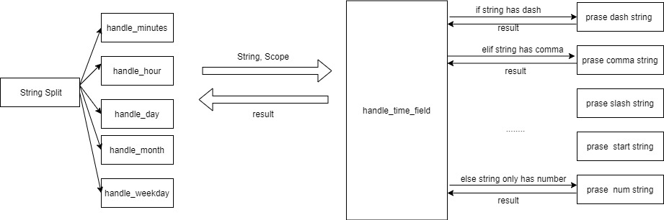**Design**

The input string will be split. If the number of time field is correct, for each time field, I used a function called “handle_field” to handle it. This function has two parameters. One is the string needed to be parsed and the other is the range .For example, for time field minute, the range will be [0,59].

1. **File Structure**

**--prase_symbol.py**

Parse strings containing different symbols. Use regular expression to verify string.

**--main.py**

The main process of parsing a cron string input.

**--test.py**

Unit tests for each symbol resolution function

Please contact aidazhengxun@163.com if there's any issue.